Initial Analysis Result: Storm Water Discharge Safety Report for CT
Data Cleaning and Formatting:
The data was available in two excel files. One file recorded information from 1995 – 2012 and the other more updated file recorded information from 2011 – 2014. The newer data had all the industries classified into 12 broad sectors. We intended to use this classification, and hence both the data were made compatible through thorough data cleaning and formatting. We used SIC codes to identify and map industries to sectors. Some of the SIC codes from the old file did not match any from the newer data so, temporarily we have left those out and went on with our analysis.
Project Goal 1:
How are the nutrients and sediments pollutant levels declining over time? Is TSS decreasing at a faster rate than nutrients?
Actions:
We provide graphical exploratory analysis results. LOESS method was applied to produce smooth non-parametric plots for each of the nutrients and the sediments over time. The plots allow us to study the behavior of the overall data through time. We do not plot individual points, as it is quite impossible to discern any pattern looking at the data due to presence of quite a few outliers.
For Reference we list the sectors and the numbers that represent them:
Sector | Number
General and Sec-G Transport | 1
A - Asphalt | 2
B – Mines & Quartz | 3
C - Refuse | 4
D – Auto Sal | 5
E – Scrap Recycling | 6
F – Steam Gen | 7
G – Small Air | 8
G – Muni & Fed | 9
G - DOT | 10
H – Marina & Boat | 11
I – Ship Building & Repair | 12

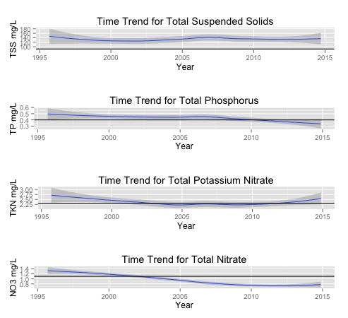

Observation:

- Total phosphorus (TP) and total Nitrate (NO3) pollutant loadings exhibits a decreasing trends, dipping below the new benchmarks
- Total Suspended Solids (TSS) shows more or less a constant trend during the past years, however we cannot claim from the plots that it is decreasing.
- Total potassium nitrate (TKN) shows increasing trends in recent past, after exhibiting stable constant trend in the first decade of 2000.
We are also going to look at the trends of each nutrient and pollutant over all industrial sectors.
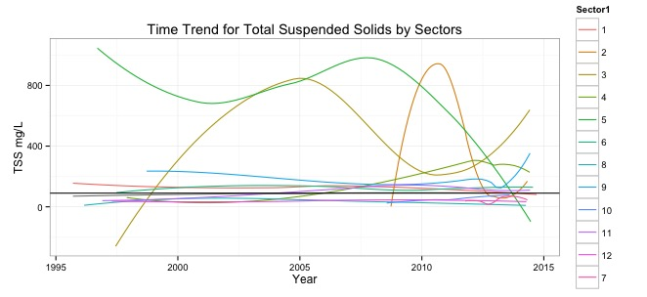

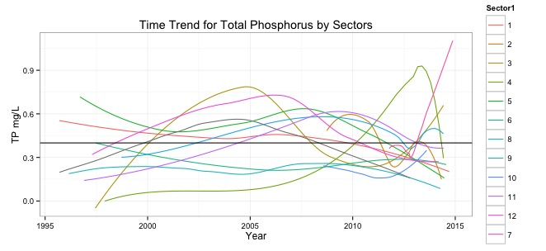
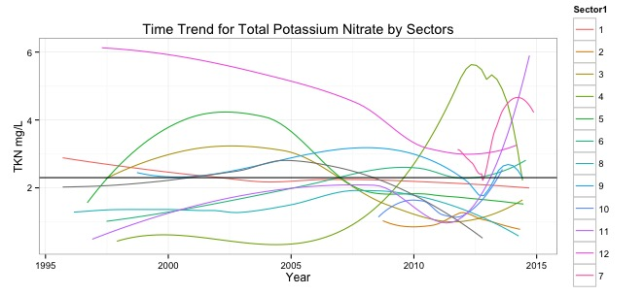
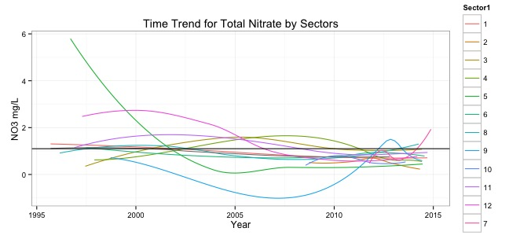

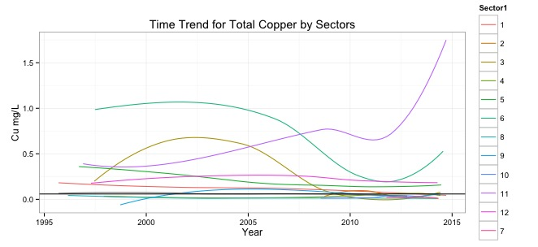
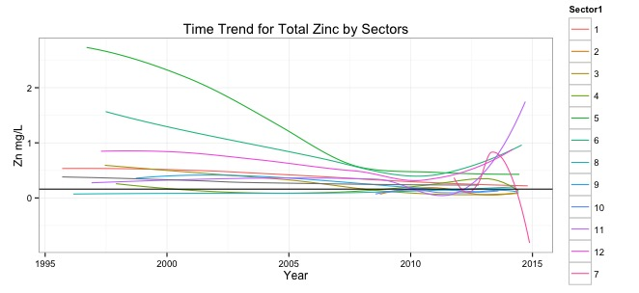

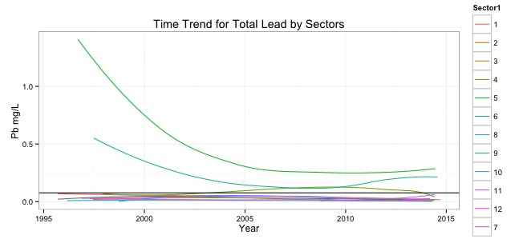
Observation:

- Total suspended solids (TSS) exhibit sharp decreasing trend for Sector 5, Sectors 2, 3, 4, 9 and 7 show increasing trends.
- Total Nitrates (NO3): Only Sector 7 shows increasing trend in recent times
- Total Potassium Nitrates (TKN), Sectors 7, 11, 12 and 8 exhibit increasing trends. Sector 4 after increasing from 2005 – 2012, now shows a steep decrease.
- Total Phosphorus (TP), Sector 7, 3 shows sharp increasing trends, Sector 11, although below limit, is on the rise. Sector 4 exhibits similar behavior wr.t. TP as with TKN.
- Total zinc (Zn), sectors 6, 11 and 12 are the only ones with increasing trends. Sector 7 shows a sharp decrease.
- Total copper (Cu), sectors 11, 6 and 3 shows increasing trends.
- Total lead (Pb), sectors 5 and 6 are the only ones above the benchmark.

Project Goal 2:
How are the nutrients and sediments pollutant levels declining over time with respect to individual sectors?
Actions:
We provide graphical exploratory analysis for each sector individually.
Observation:

- For Sector 1: all trends are decreasing except that of total nitrate, which is beginning to show an increasing trend.

Observation:

- For Sector 2: All trends are stable around the benchmark except total suspended solids, which shows a slightly increasing trend in the recent past.
Observation:

- For Sector 3: Total Suspended Solids and Phosphates are showing increasing trends, others look stable. It is to be noted that TSS displays more variation than the others resulting in wider standard error bands.
Observation:
For Sector 4: Total suspended solids, phosphates, total Kjehldahl nitrogen and the nitrates show increasing trends while others are stable around preferred benchmark.
Observation:
For Sector 5: All trends are decreasing especially TSS and zinc.
Observation:
For Sector 6: All trends are stable except copper, zinc and lead which are beginning to an increasing trend.
Observation:
For Sector 7: Phosphates, total Kjehldahl nitrogen and the nitrates show increasing trends.
Observation:
For Sector 8: All trends appear stable.
Observation:
For Sector 9: Nitrates might display an increasing trend in near future.
Observation:
For Sector 10: Phosphates and total Kjehldahl nitrogen might display an increasing trend in near future.
Observation:
For Sector 11: Copper, Zinc and total Kjehldahl nitrogen show an increasing trend.

Observation:
For Sector 12: All trends are stable or decreasing except that for zinc and total Kjehldahl nitrogen.
Conclusion:

- Your suggestions/conclusions/remarks after the analyses

We also provide in depth spatial views of CT Towns over years with respect to each pollutant and nutrient. Each town has been color coded in three ways. Light pink implies the recorded value of the pollutant/nutrient is below or equal to the benchmark provided by DEEP, red implies over the benchmark but not alarmingly high, while the darkest brown implies that the value is very high and at least 5 – 10 times the benchmark value. An example plot is provided. Automated choropleths were produced for each pollutant and nutrient.
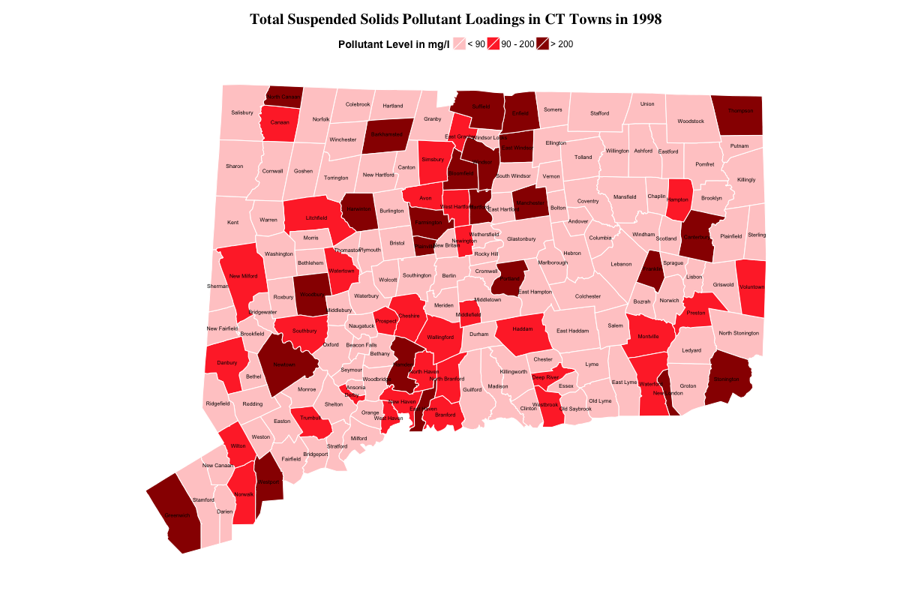

Project Goal 3:
To dig deeper, we try to find “hot towns”. These are defined as towns, which have violated benchmarks for 3 out 7 (total suspended solids, total phosphates, total Kjehldahl nitrogen, total ntrates, total lead, total zinc and total copper) pollutants or nutrients. We classify these towns into 4 groups: Very High Risk (Towns which have violated 3/7 water safety parameters for last 20 years), High-Risk (Towns which have violated 3/7 water safety parameters for last 15 years), Mid-Risk (Towns which have violated 3/7 water safety parameters for last 10 years) and Low-Risk (Towns which have violated 3/7 water safety parameters for last 5 years).

RESULTS:

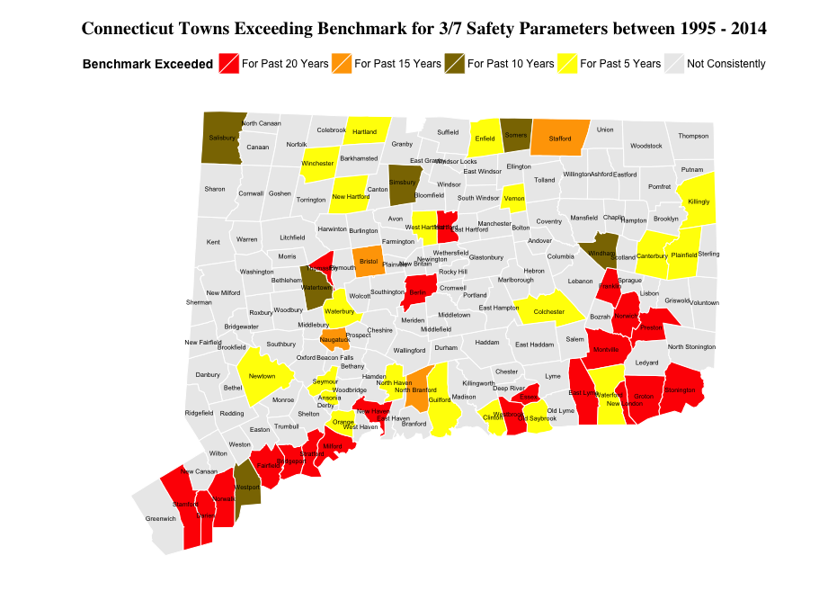
Observation:
We find 21 very high-risk towns including Bridgeport, Fairfield, Norwalk, Stamford and New London, which have exceeded the benchmark in at least 3 out of 7 water safety parameters for the past 20 years.

Our analysis shows there are 4 towns, which have been exceeding the benchmarks for 3 out of 7 safety parameters for the past 15 years, 6 towns, which have been exceeding the benchmarks for 3 out of 7 safety parameters for the past 10 years and 20 other towns, which have been exceeding the benchmarks for 3 out of 7 safety parameters for the past 5 years.

